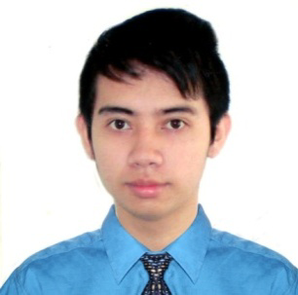

**Bon Lenard T. Caoyong**

MRH Bldg. 3 – A Unit 105, Malaria

Caloocan City

09610013267

[bonlenardtcaoyong@yahoo.com](mailto:bonlenardtcaoyong@yahoo.com)

**______________________________________________________________________________**

**Professional Objectives**

* To obtain a position that will enable me to use my strong organizational skills, educational background, work experiences, ability to work well in any vacant position, and to work well with other people.

**______________________________________________________________________________**

**Education and Certification**

(2008 – 2012) **University of Caloocan City:**

B.S Psychology Major in Guidance and Counseling

**Siena College of San Jose:**

* 200 hours as Guidance and Counselor

**SANDIGANBAYAN:**

* 200 hours of H.R position

**Philippine Information Agency (PIA)**

* 40 hours of H.R job

**______________________________________________________________________________**

**Skills**

* Excellent in verbal and written skills in English
* Work effectively to create compelling, engaging and good quality deliverables
* Critically evaluate evidence and interpret data deliberately
* Ability to clearly understand and act on presented problem statement
* Highly understand the Human Resource policies, procedures, and tools
* Proficient in the use of Microsoft Office (e.g. Word, Excel and Power Point)
* Strong time management, prioritize and multi-tasking skills

**Work Experience and Responsibilities**

**Health PlusMedical Clinic (2013 - 2014)**

* Psychologist / Assistant Psychometrician

-Responsible for scoring psychological exam

-Profiling and interpreting personality test results

-Conducts counseling to those with underlying personal, family, social-interpersonal problems

**Hannah Medical Clinic (2014 - 2015)**

* Psychologist

-Asses and prevent in diagnosing a mental health condition for a patient

-Counsel patients on a one-to-one basis, focusing on life skills and behavior modification

-Formulating a psychological explanation of the client’s issues

-Planning and implementing therapy

-Evaluating the outcome of therapy

-Training and supervision of other psychologists

**Oxychem Corporation (2015 - 2015)**

* HR Staff

-Provides job candidates by screening, interviewing, and testing applicants

-Provides payroll information by collecting time and attendance records

-Maintaining and tracking employee records

-Orients new employees

-Identifies hiring need, develops the position description, recruitment plan, organizational chart and other recruitment related documents

-Maintains employee confidence and protects operations by keeping human resource information confidential

**AVIS (Rent a Car) (2017 - 2018)**

* HR Staff

-Provides job candidates by screening, interviewing, and testing applicants

-Provides payroll information through Integra Software and manually.

**TOPNOTCH (Medical Board Preperation)**

**(2018 - 2019)**

* Administrative Staff

- Assisting Medical Students